Digital Media Integration In English Language Teaching: Its Impact On Young Learners' Speaking Confidence And Engagement

Integrasi Media Digital Dalam Pengajaran Bahasa Inggris: Dampaknya Terhadap Kepercayaan Diri Berbicara Dan Keterlibatan Pembelajar Usia Dini

Rini Artika¹, Wahyuni Fitria², Eliza Trimadona³
Universitas Islam Negeri Sulthan Thaha Saifuddin Jambi (UIN STS Jambi)^{1,2,3}
Email: rinijambi838@gmail.com¹, wahyunifitria@uinjambi.ac.id², elizatrimadona@uinjambi.ac.id³

*Corresponding Author

Received : 20 Mei 2026, Revised : 16 Juni 2026, Accepted : 22 Juli 2026.

ABSTRACT
This study examines the integration of digital media in English language teaching and its impact on young learners’ speaking confidence and classroom engagement at the primary school level. Conducted at Excellent Mandiri School, Kota Jambi, Indonesia, this qualitative study employed structured classroom observations across twelve English lessons involving fourth- to sixth-grade elementary students. A systematic observation protocol was used to identify indicators of speaking confidence, including voluntary oral participation, spontaneous English production, and avoidance behaviors, as well as student engagement across various learning activities. The findings demonstrate a clear difference between digital media-supported and non-digital learning phases. Digital media activities generated substantially higher levels of speaking confidence, with positive speaking behaviors occurring more than twice as often as those observed during conventional instruction. Students also showed high engagement rates across digital activities, ranging from 74% to 95%, compared with 48% during teacher-centered explanations. Animated educational videos and digital songs encouraged sustained participation, while interactive quiz applications stimulated the highest level of active involvement. Differences among learner responses and the gradual increase in confidence indicators suggest that digital media integration serves not only as a motivational tool but also as a mechanism for developing communicative confidence over time. These findings highlight the importance of purposeful digital media integration in primary EFL classrooms and provide implications for teacher development, curriculum innovation, and educational policy in Indonesia.
Keywords: digital media integration, English language teaching, speaking confidence, student engagement, young learners.

ABSTRAK
Penelitian ini mengkaji integrasi media digital dalam pengajaran bahasa Inggris serta dampaknya terhadap kepercayaan diri siswa dalam berbicara dan keterlibatan mereka di kelas pada tingkat sekolah dasar. Penelitian kualitatif yang dilaksanakan di Excellent Mandiri School, Kota Jambi, Indonesia ini menggunakan metode observasi kelas terstruktur pada dua belas sesi pembelajaran bahasa Inggris yang melibatkan siswa kelas empat hingga kelas enam. Protokol observasi sistematis digunakan untuk mengidentifikasi indikator kepercayaan diri dalam berbicara—seperti partisipasi lisan secara sukarela, penggunaan bahasa Inggris secara spontan, dan perilaku menghindar—serta tingkat keterlibatan siswa dalam berbagai aktivitas pembelajaran. Hasil penelitian menunjukkan perbedaan yang nyata antara tahapan pembelajaran yang didukung media digital dan tahapan pembelajaran tanpa media digital. Aktivitas berbasis media digital menghasilkan tingkat kepercayaan diri berbicara yang jauh lebih tinggi; perilaku berbicara yang positif muncul lebih dari dua kali lipat dibandingkan dengan yang teramati selama pembelajaran konvensional. Siswa juga menunjukkan tingkat keterlibatan yang tinggi dalam aktivitas digital, berkisar antara 74% hingga 95%, dibandingkan dengan 48% saat sesi penjelasan yang berpusat pada guru. Video edukasi animasi dan lagu digital mendorong partisipasi yang berkelanjutan, sementara aplikasi kuis interaktif memicu tingkat keterlibatan aktif tertinggi. Variasi respons siswa dan peningkatan bertahap pada indikator kepercayaan diri mengisyaratkan bahwa integrasi media digital tidak hanya berfungsi sebagai sarana motivasi, tetapi juga sebagai mekanisme untuk membangun kepercayaan diri dalam berkomunikasi seiring berjalannya waktu. Temuan ini menegaskan pentingnya integrasi media digital yang terarah dalam pembelajaran bahasa Inggris (EFL) di sekolah dasar serta memberikan implikasi bagi pengembangan kompetensi guru, inovasi kurikulum, dan kebijakan pendidikan di Indonesia.
Kata kunci: integrasi media digital, pengajaran bahasa Inggris, kepercayaan diri berbicara, keterlibatan siswa, siswa usia dini/sekolah dasar.

1. Introduction

The rapid development of digital technology in recent decades has brought significant changes to the structure, implementation, and learning environments of education worldwide. In the context of English Language Teaching (ELT), technological advancement has encouraged a transition from traditional teacher-centered and textbook-based approaches toward more interactive, multimodal, and digitally supported learning models. Digital media in ELT encompasses various technological resources, such as educational videos, language learning applications, animated content, digital audio, interactive platforms, and visual materials delivered through digital devices. These resources are not merely technological additions but represent a broader pedagogical transformation in how learners receive, process, and construct linguistic knowledge. When integrated effectively, digital media can provide meaningful exposure to authentic English input and create richer language learning experiences, particularly for learners with limited opportunities to encounter English outside the classroom (Cabello et al., 2021).
Primary school learners represent a distinctive group in English language education because their learning processes are strongly influenced by cognitive, emotional, and social development. At this stage, children generally respond more positively to learning activities that involve interaction, exploration, creativity, and meaningful experiences. Early experiences with English play an important role in shaping learners’ attitudes, motivation, and willingness to communicate. Learning environments that are perceived as stressful, monotonous, or irrelevant may reduce learners’ interest and confidence, while supportive and engaging classrooms can encourage positive attitudes and stronger communication skills (Graves, 2023).
Among various aspects of English proficiency, speaking ability is particularly important because it reflects learners’ capacity to use language for real communication. Developing speaking skills requires the integration of multiple processes, including pronunciation, vocabulary selection, sentence formation, contextual understanding, and self-monitoring. For young EFL learners, these demands are often accompanied by emotional challenges, such as fear of making mistakes, uncertainty about pronunciation, and limited experience using English communicatively. Therefore, speaking confidence becomes a crucial factor that influences students’ willingness to participate, express ideas, and continue practicing despite difficulties. Learners with higher confidence are generally more active in oral communication activities and have greater opportunities to develop their speaking competence (Feng et al., 2025).
Digital media has been increasingly identified as a potential strategy for overcoming psychological barriers that restrict young learners’ participation in speaking activities. Through animated videos, digital songs, interactive games, and multimedia presentations, students can experience English in more engaging, meaningful, and less intimidating situations. Digital environments provide opportunities for learners to observe pronunciation models, acquire vocabulary in context, and understand communicative expressions through the combination of audio, visual, and textual representations. Such exposure allows students to gradually build familiarity with English without experiencing excessive pressure from direct performance situations. Based on the Cognitive Theory of Multimedia Learning, the combination of verbal and visual information can improve learning effectiveness by supporting deeper understanding and reducing unnecessary cognitive demands (Mayer, 2021).
In addition to supporting speaking development, digital media also plays an important role in increasing student engagement. Engagement refers to the extent to which learners invest behavioral, emotional, and cognitive efforts in learning activities. In primary EFL classrooms, students’ willingness to participate, maintain attention, and interact in English is closely associated with how meaningful, enjoyable, and relevant they perceive classroom activities to be. Previous research indicates that learners who frequently interact with English through digital platforms tend to demonstrate stronger motivation, greater willingness to communicate, and more positive attitudes toward English learning (Han et al., 2024). This suggests that digital media can create continuous motivational influences that extend beyond classroom activities.
Within the Indonesian educational context, English is recognized as an important foreign language subject introduced at various educational levels, including primary schools. The increasing availability of digital infrastructure has encouraged wider adoption of technology in language learning. However, primary English education in Indonesia still faces several challenges, including limited resources, large classroom populations, and instructional practices that often emphasize knowledge transmission rather than active communication. At the same time, Indonesian children are becoming increasingly familiar with digital technologies in their daily lives, creating opportunities to connect informal digital experiences with formal English learning. Studies in Asian EFL contexts have shown that learners with greater access to authentic digital English content tend to demonstrate stronger communication engagement and higher speaking confidence (Friedman, 2023). Furthermore, mobile-based learning has been associated with improved vocabulary acquisition and increased motivation when implemented through appropriate pedagogical approaches (Garzón et al., 2023).
Although previous studies have demonstrated the benefits of digital technology for various aspects of English learning, including vocabulary development, listening comprehension, reading ability, and grammatical knowledge, research focusing specifically on the influence of classroom digital media integration on young learners’ speaking confidence and engagement remains limited. Existing studies also highlight that teachers’ digital competence is an essential factor in creating effective, learner-centered, and communicative technology-supported classrooms (Godwin-Jones, 2021). However, empirical evidence regarding how digital media directly shapes young learners’ oral confidence and participation, particularly in primary school EFL settings, requires further investigation.
Therefore, this study aims to examine the integration of digital media in English language teaching at a primary school in Kota Jambi, Indonesia, with particular attention to its observable effects on students’ speaking confidence and classroom engagement. By employing a naturalistic observational approach within an authentic educational setting, this research seeks to provide deeper insights into the role of digital media as a pedagogical resource for developing communicative confidence and sustained learner participation. The findings are expected to contribute to the advancement of EFL teaching practices, teacher development programs, and curriculum planning for technology-enhanced English education in developing educational contexts.

2. Literature Review

Digital Media Integration in English Language Teaching
The incorporation of digital media into English Language Teaching (ELT) has experienced significant development over the past two decades, evolving from an optional instructional aid into an essential element of modern language education. Digital media, which includes animated videos, multimedia presentations, educational applications, digital audio resources, and interactive learning platforms, has expanded the range of instructional strategies available to English teachers in various educational settings. These technologies provide opportunities to create more interactive, communicative, and learner-centered learning environments, particularly for students who have limited exposure to authentic English outside the classroom. Research by Başar and ŞAHİN (2021) demonstrated that the purposeful implementation of digital tools in EFL classrooms contributes to more meaningful language interactions and supports students’ engagement with English learning activities. Similarly, Shadiev and Yang (2020) highlighted that technology-enhanced language learning environments are associated with increased learner motivation, improved oral language performance, and more positive attitudes toward English communication. Therefore, digital media should not be viewed merely as technological innovation but as a pedagogical resource that transforms the ways learners access, process, and acquire language knowledge.

Speaking Confidence Among Young EFL Learners
Speaking confidence represents a crucial psychological factor influencing young learners’ success in developing English communication skills. It affects students’ willingness to participate in oral activities, initiate conversations, and overcome mistakes during the process of language development. Feng et al. (2025) revealed that speaking confidence among young EFL learners develops dynamically through continuous interaction between learners and their classroom environments. Students who experience supportive and less threatening communication contexts tend to develop stronger motivation and greater willingness to use English orally. In contrast, learning environments dominated by evaluation pressure and fear of mistakes may reduce students’ participation and create communication barriers.
For primary-level EFL learners, confidence development is particularly important because children are still forming their perceptions of language learning, including their willingness to experiment, tolerate errors, and take communicative risks. Therefore, effective English instruction should provide sufficient opportunities for meaningful language exposure, supportive interaction, and gradual oral practice to reduce anxiety and encourage confident communication.

Theoretical Foundation: Cognitive Theory of Multimedia Learning
The Cognitive Theory of Multimedia Learning proposed by Mayer (2021) provides an important theoretical foundation for explaining how digital media influences language learning processes. This theory suggests that human learning occurs through two primary cognitive systems: verbal and visual channels. Learning becomes more effective when information is presented through both channels in an organized and meaningful manner.
In English language learning, multimedia resources such as animated videos, audio-visual materials, and interactive presentations enable students to connect spoken language with visual representations, resulting in stronger understanding and memory retention. Compared with traditional single-mode instruction, multimedia-based learning allows learners to construct richer mental representations of linguistic information while reducing unnecessary cognitive demands. In the context of speaking development, digital media provides accessible language models that support pronunciation, vocabulary acquisition, and contextual understanding, creating cognitive and emotional conditions that encourage more confident oral communication.

Student Engagement in Technology-Enhanced Language Learning
Student engagement refers to the degree of behavioral, emotional, and cognitive involvement that learners demonstrate during educational activities. It is widely recognized as an important determinant of learning achievement, motivation, and continued participation. In technology-supported language learning environments, digital media has been shown to enhance students’ involvement by creating interactive, meaningful, and enjoyable learning experiences.
Han et al. (2024) found that learners who frequently interact with English through digital platforms demonstrate stronger willingness to communicate and more positive attitudes toward English learning. These findings suggest that digital engagement can influence students’ broader learning orientations beyond the immediate classroom activity. Furthermore, Chiu (2021), through the perspective of self-determination theory, explained that technology-mediated learning environments can support students’ psychological needs for competence, autonomy, and social interaction, which are essential factors for maintaining sustained engagement in learning activities.

Digital Media and Affective Development in Oral Language Learning
The affective dimension of language learning has become an important area of research in understanding the role of digital media in developing speaking abilities. Zhang and Zou (2021) found that multimedia-based language input contributes to improved oral production and creates more positive emotional experiences among EFL learners. Digital media provides contextualized and meaningful language exposure through stories, songs, videos, and interactive activities, allowing students to encounter English in a less stressful environment compared with conventional speaking practices.
The reduced psychological pressure provided by digital learning environments enables learners to engage with English expressions more naturally and gradually develop confidence in oral communication. Similarly, Garzón et al. (2023) reported that mobile-based digital learning interventions are positively associated with increased motivation and improved learning outcomes among EFL learners. These findings indicate that digital media functions not only as a motivational tool but also as a strategic pedagogical mechanism that supports the development of communicative confidence and sustained engagement among young English learners. Overall, previous theoretical and empirical studies demonstrate that purposeful digital media integration plays an important role in creating supportive learning environments that facilitate speaking confidence, active participation, and effective English language development in primary school contexts.

- Research Methodology

Research Design and Approach
This study employed a qualitative research approach to explore the integration of digital media in English language teaching and its observable influence on young learners’ speaking confidence and classroom engagement at the primary school level. A qualitative design was selected because the study aimed to gain an in-depth understanding of how digital media-based teaching practices shape students’ behaviors, participation, and emotional responses within a natural classroom environment. According to Creswell and Creswell (2018), qualitative research is appropriate for examining complex educational phenomena by emphasizing contextual understanding rather than statistical measurement or broad generalization. Therefore, this approach enabled the researcher to examine the classroom dynamics, learner interactions, and experiences associated with digital media implementation in primary EFL instruction.

Research Setting and Context
The study was conducted at Excellent Mandiri School, located at Jl. Sk. Rd. Syahbudin No. 91, RT. 22, Mayang Mangurai, Kota Baru, Jambi, Indonesia. The school was selected as the research site because digital media had already been integrated into its English teaching practices. Teachers regularly utilized various digital resources, including audio-visual materials, animated instructional videos, educational applications, and multimedia presentations as part of classroom instruction. This existing implementation provided an authentic context for examining the role of digital media without introducing artificial experimental conditions. Furthermore, the urban primary school environment in Kota Jambi represents a relevant setting for investigating the opportunities and challenges of technology-supported English learning within the Indonesian EFL context.

Participants and Sampling Technique
The participants of this research were primary school students who attended English language classes at Excellent Mandiri School. The study focused on learners in grades four to six, with participants approximately between nine and twelve years old. This group was selected because students at this developmental stage have sufficient cognitive and linguistic abilities to participate in structured English activities while still being categorized as young learners in EFL education research. A purposive sampling technique was applied to select classroom sessions where digital media integration was consistently implemented, ensuring that the observed learning activities were directly relevant to the objectives of the study.

Data Collection Method
Data were collected through structured classroom observations. Observation was chosen as the primary data collection method because it allows researchers to capture authentic classroom behaviors, interactions, and learning processes as they naturally occur (Cohen et al., 2018). The use of observation was considered appropriate for young learners, who may have limited ability to provide detailed reflections about their own learning experiences through interviews or questionnaires. Therefore, direct observation provided a more reliable means of identifying behavioral evidence related to speaking confidence and student engagement. A structured observation instrument was developed to identify observable indicators of speaking confidence and engagement. Speaking confidence was examined through indicators such as voluntary participation in English conversations, willingness to answer teacher questions, clarity and fluency of oral responses, and reduced avoidance behaviors during speaking activities. Meanwhile, student engagement was observed through active participation in digital media activities, sustained attention during multimedia presentations, responses to digital learning stimuli, and involvement in follow-up speaking tasks.

Observation Procedure
The observation process was conducted across several English learning sessions during the research period to obtain diverse and consistent behavioral data. The researcher acted as a non-participant observer by observing classroom activities without interfering with the teaching and learning process. Field notes were systematically recorded to document instructional sequences, types of digital media used, student responses, classroom interactions, and patterns of oral communication between teachers and students. In addition, reflective notes were maintained to record emerging interpretations and analytical considerations throughout the data collection process (Merriam & Tisdell, 2015).

Data Analysis and Research Trustworthiness
The collected observation data were analyzed using an inductive thematic analysis approach. Field notes from each observation session were reviewed, coded, and categorized based on recurring patterns related to speaking confidence and student engagement. Initial codes were generated from observed behaviors and subsequently organized into broader thematic categories representing the main research constructs. The constant comparative method was applied to identify similarities, differences, and emerging patterns across observation sessions. The credibility of the findings was maintained through continuous engagement at the research site, consistent use of the observation framework, systematic documentation procedures, and researcher reflection throughout the analytical process. These strategies ensured that the interpretation of findings accurately represented the influence of digital media integration on young learners’ speaking confidence and engagement in the primary EFL classroom context.

- Results And Discussion

Implementation of Digital Media Integration in English Language Teaching at Excellent Mandiri School
The observations conducted during twelve English language learning sessions at Excellent Mandiri School provided comprehensive insights into the implementation of digital media within classroom instruction. The findings indicate that digital media was not merely used as an additional teaching resource but had become an integral component of the instructional process. It functioned as a primary medium for introducing language materials, providing models of spoken English, and supporting classroom activities designed to encourage student participation and interaction. The classroom environment was equipped with technological facilities that supported digital-based learning, including a projector, teacher-operated laptop, and speaker system for presenting audio-visual materials. These facilities enabled teachers to utilize various digital resources throughout the observed lessons, such as animated educational videos, multimedia presentations containing visual and audio elements, digital English songs with lyric displays, short English narration videos, and interactive quiz applications. The availability of these resources created a more dynamic learning environment and allowed students to experience English through multiple modes of input.
A significant finding from the observation was the teacher’s strategic selection and application of digital media based on specific instructional objectives. Multimedia presentations were primarily used during the introduction of new concepts and vocabulary development by providing visual support that helped students understand unfamiliar language items before practicing them orally. Animated videos were frequently incorporated during language modeling and guided practice activities, allowing students to observe authentic pronunciation, vocabulary use, and conversational patterns in meaningful contexts. Meanwhile, digital songs were commonly utilized during review activities or transitions between tasks, helping reinforce pronunciation patterns while maintaining students’ interest and motivation.
These practices demonstrate that digital media integration at Excellent Mandiri School was implemented through a purposeful pedagogical approach rather than simple technology adoption. Each type of digital resource was selected according to its instructional function, supporting both cognitive processes and affective aspects of language learning. The findings suggest that well-planned digital media use can enhance English learning experiences by providing meaningful language exposure, encouraging active participation, and creating supportive conditions for young learners’ communicative development.
Table 1. Types and Frequency of Digital Media Tools Used in English Lessons at Excellent Mandiri School (N = 12 Observed Sessions)
No. | Digital Media Tool Type | Frequency (Number of Sessions) | Percentage (%) | Primary Pedagogical Function in Lesson
1 | Multimedia Slide Presentations | 12 | 100.0% | Vocabulary input and concept scaffolding
2 | Animated Educational Videos | 10 | 83.3% | Oral language modeling and narrative comprehension
3 | Digital Songs / Audio Tracks | 7 | 58.3% | Phonological awareness, pronunciation practice, and affective engagement
4 | Short English Narration Clips | 5 | 41.7% | Listening stimulation and speaking prompts
5 | Interactive Quiz Applications | 4 | 33.3% | Vocabulary reinforcement and competitive learning engagement
Source: Classroom observation data at Excellent Mandiri School (2025).
As presented in Table 1, multimedia slide presentations emerged as the most frequently utilized digital resource, appearing in every observed lesson session. Animated educational videos were also widely implemented, being incorporated into more than 80% of the classroom observations. Digital songs were used in over half of the sessions, indicating that teachers intentionally employed musical elements and rhythmic activities to support pronunciation development and enhance students’ emotional involvement in learning. Although interactive quiz applications had the lowest frequency of use among the observed digital tools, they produced notably strong levels of student participation and behavioral engagement during the sessions in which they were implemented. This pattern will be further explored in the following sections of the discussion.
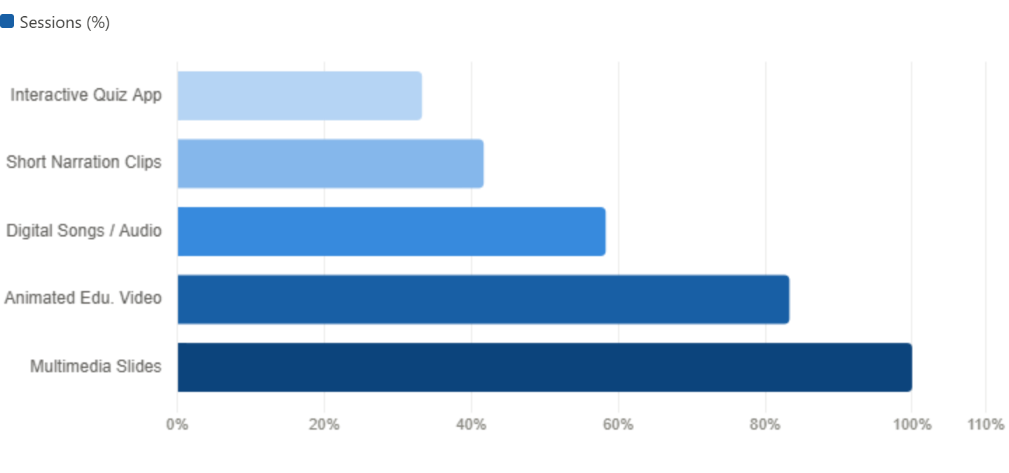
Figure 1. Percentage of Observed Sessions Featuring Each Digital Media Tool Type

Digital Media Integration and Young Learners’ Speaking Confidence
The connection between digital media integration and students’ observable speaking confidence represented one of the most prominent findings throughout the observation period. In this study, speaking confidence was identified through several behavioral indicators demonstrated during classroom interactions. The findings showed that students exhibited significantly stronger speaking confidence during learning activities supported by digital media compared with conventional teacher-led explanation sessions without technological assistance. The observation framework assessed five main indicators: voluntary oral participation without direct teacher prompts, spontaneous use of English expressions, production of clear and complete spoken responses, reduction of avoidance behaviors such as silence or hesitation during speaking tasks, and students’ ability to imitate English vocabulary, phrases, and pronunciation patterns presented through digital media.
During activities involving animated educational videos, many students who were previously less active during traditional explanation phases began to participate more actively by repeating English words shown in the videos, completing sentences modeled by animated characters, and imitating pronunciation patterns from digital audio sources. This response was particularly visible among students who were initially considered reluctant English speakers based on repeated classroom observations. During non-digital activities, these learners frequently demonstrated hesitation, limited participation, or avoidance when asked to speak English. However, when digital videos and songs were introduced, they showed greater willingness to produce spoken English and participate in front of their classmates.
The reduction of visible anxiety during digital media-based activities suggests that multimedia learning environments may create a more supportive and less intimidating atmosphere for young EFL learners. The combination of visual, auditory, and contextual elements appears to reduce the pressure associated with direct speaking performance while providing accessible language models for students to follow. This finding supports previous research in technology-enhanced language learning, which indicates that digitally supported learning environments can reduce affective barriers and encourage greater communicative participation by providing meaningful, engaging, and context-rich exposure to the target language (Başar & ŞAHİN, 2021).

Table 2. Comparative Frequency of Speaking Confidence Behavioral Indicators Across Digital Media and Non-Digital Lesson Phases (Average per Session; N = 12 Sessions)
No. | Speaking Confidence Behavioral Indicator | Digital Media Phase (Average/Session) | Non-Digital Phase (Average/Session) | Observed Differential
1 | Voluntary Oral Responses | 14.3 | 6.7 | +7.6
2 | Spontaneous English Utterances | 8.9 | 2.4 | +6.5
3 | Audible Full-Sentence Responses | 11.2 | 4.8 | +6.4
4 | Avoidance Behaviors (Silence/Withdrawal) | 3.1 | 9.6 | −6.5
5 | Repeated English Phrases from Digital Media | 10.4 | 1.2 | +9.2
Source: Classroom observation data at Excellent Mandiri School (N = 12 sessions).
The behavioral patterns presented in Table 2 provide strong evidence regarding the influence of digital media on young learners’ speaking confidence. Across all positive indicators of speaking performance, digital media-supported learning phases consistently produced higher levels of student participation compared with non-digital instructional phases. Voluntary oral responses, for example, reached an average of 14.3 occurrences per session during digital media activities, compared with only 6.7 occurrences during conventional teaching phases. This difference indicates that digitally supported instruction more than doubled students’ spontaneous willingness to participate orally.
The largest variation was observed in students’ ability to reproduce English expressions, vocabulary, and phrases modeled through digital media. During digital media sessions, this behavior appeared an average of 10.4 times per session, while non-digital sessions recorded only 1.2 occurrences. This substantial gap suggests that digital media functions not only as a supporting instructional resource but also as an active language model that encourages learners to imitate, practice, and produce English orally. Through repeated exposure to audio-visual language input, students were provided with accessible examples of pronunciation, sentence patterns, and authentic expressions.
In addition, avoidance behaviors such as silence, hesitation, or withdrawal occurred less frequently during digital media-based activities, decreasing from 9.6 occurrences per session in non-digital phases to 3.1 occurrences during digital phases. This reduction indicates that technology-supported learning created a more comfortable and encouraging classroom atmosphere for oral communication. These findings support previous studies showing that multimedia-based language learning environments can enhance learners’ target language production while improving their emotional readiness and confidence in speaking activities (Zhang & Zou, 2021).
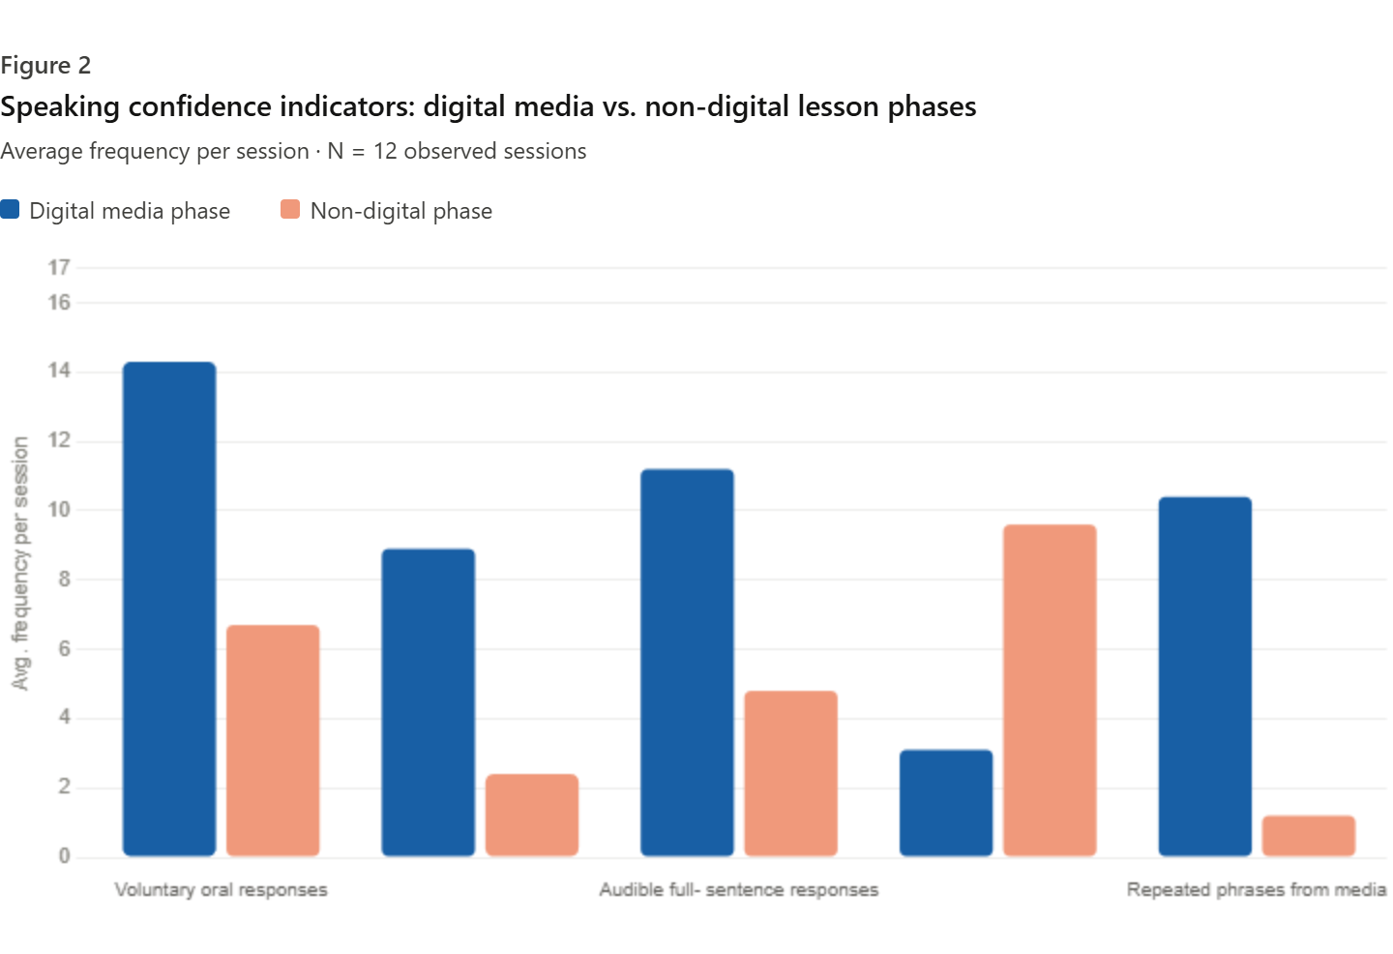
Figure 2. Average Frequency of Speaking Confidence Indicators During Digital Media vs. Non-Digital Lesson Phases
Digital Media Integration and Student Engagement
The observational findings related to student engagement across twelve classroom sessions revealed consistent evidence that digital media integration contributed to increased levels of behavioral, emotional, and active participation among primary EFL learners. Student engagement was examined through several observable dimensions, including students’ ability to maintain attention during learning activities, their level of active participation in classroom tasks, their spontaneous responses toward digital content, and the occurrence of disengaged behaviors such as loss of focus, inactivity, or passive participation. These indicators were systematically documented across different learning activities to compare students’ engagement patterns during digital media-supported instruction and conventional non-digital teaching phases.
The findings demonstrated that digital media-based activities consistently encouraged stronger learner involvement. Students showed sustained attention, active interaction, and positive emotional responses when engaging with digital learning materials. During animated video activities, learners were frequently observed focusing on the screen, repeating English words and expressions from the content, pointing at visual elements, and discussing aspects of the videos with their peers. These behaviors indicate that students were not only watching the materials but also actively processing and responding to the language input provided.
Compared with traditional teacher-centered explanations, digital media activities generated more interactive and participatory classroom behaviors. Students appeared more willing to respond, communicate, and engage with learning materials when lessons incorporated visual and auditory elements. Digital song activities produced particularly strong engagement, as students participated by following rhythms, clapping, repeating lyrics, and singing English expressions together. Such responses reflected genuine interest and enjoyment rather than simple compliance with teacher instructions. These findings suggest that digital media creates a more stimulating and emotionally supportive learning environment that encourages young learners to participate actively in English learning activities (Perez et al., 2023).
Table 3. Student Engagement Profile Across Digital Media Activity Types and Non-Digital Instruction (N = 12 Sessions)
No. | Activity Type | Average Engagement Duration (Minutes/Session) | Average Active Participation Rate (%) | Dominant Behavioral Engagement Indicators
1 | Animated Educational Video | 12.4 | 87% | Attentive gaze, oral imitation, peer commentary
2 | Digital Song Activity | 8.6 | 91% | Singing, rhythmic movement, vocal responses
3 | Multimedia Slide Presentation | 10.2 | 79% | Answering questions, pointing, attentive tracking
4 | Short English Narration Clip | 7.8 | 74% | Listening focus, comprehension responses
5 | Interactive Quiz Application | 6.4 | 95% | Rapid responses, competitive interaction
6 | Non-Digital Teacher Explanation | 9.1 | 48% | Passive reception, intermittent responses
Source: Classroom observation data at Excellent Mandiri School (N = 12 sessions).
The engagement patterns presented in Table 3 demonstrate a clear difference between digital media-supported activities and conventional teacher-led explanations across all observed engagement indicators. Each category of digital media activity achieved an active participation rate exceeding 70%, with digital song activities and interactive quiz applications showing the highest levels of participation at 91% and 95%, respectively. Although the interactive quiz application had the shortest average duration of use at 6.4 minutes per session due to its role as a brief review and reinforcement activity, it generated the strongest student involvement among all observed activities.
The high participation level in quiz-based activities can be explained by their interactive and competitive characteristics, which encourage students to respond directly to each question and remain actively involved throughout the activity. This structure reduces opportunities for passive behavior and promotes continuous student interaction. In contrast, non-digital teacher explanation activities recorded an active participation rate of only 48%, showing a substantial gap compared with digital media-supported activities. The difference was particularly evident when compared with interactive quizzes, which demonstrated a 47-percentage-point higher participation rate. Overall, the findings indicate that digital media consistently provides a stronger motivational impact than traditional instructional approaches in maintaining students’ involvement during English learning activities. The integration of technology-supported learning strategies appears to enhance behavioral participation, encourage interaction, and sustain communicative engagement among young EFL learners (Chiu, 2021; Shadiev & Yang, 2020).
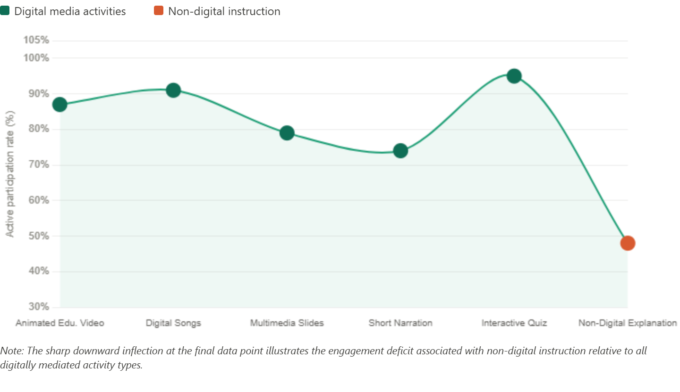
Figure 3. Comparative Active Student Participation Rates Across Activity Types (%)

Discussion
Interpreting Findings Within the Broader Academic Context
The findings of this observational study at Excellent Mandiri School provide meaningful empirical insights into the role of digital media integration in primary EFL classrooms. The consistent increase in students’ speaking confidence during digital media-supported lessons supports theoretical perspectives emphasizing the importance of affective learning environments in facilitating young learners’ oral participation. Digital media creates engaging, visually supported, and context-rich learning experiences that help reduce common psychological barriers to speaking English, such as fear of making mistakes, peer judgment, and pronunciation anxiety. The substantial increase in students’ reproduction of English phrases modeled through digital content indicates that learners were not merely exposed to digital materials but actively processed and reproduced the language input, suggesting the emergence of a digitally supported oral language development process (Bassma, 2013; Zhang & Zou, 2021).
The engagement results further demonstrate that different digital media formats stimulate different forms of learner motivation. Interactive quiz applications generated the highest participation rate due to their competitive and responsive nature, while digital song activities encouraged involvement through rhythm, movement, and enjoyment. These findings indicate that effective digital media integration does not depend on the use of a single technology, but rather on the teacher’s ability to select and combine various digital resources according to specific instructional objectives and learner needs. Such strategic use of technology is particularly relevant in Indonesian EFL classrooms, where maintaining students’ active participation in foreign language learning remains a persistent pedagogical challenge (Hoi, 2020; W. Liu & Wang, 2025).
The findings also highlight important implications for teacher professional development. Successful digital media implementation requires not only technological availability but also teachers’ pedagogical competence in selecting, organizing, and applying digital resources effectively. Teachers need to understand how different digital tools can support students’ emotional readiness, communication skills, and learning motivation. Previous research has emphasized that teacher agency and instructional design competence are essential factors determining whether technology produces meaningful learning outcomes or merely replaces traditional passive learning practices (Tai & Chen, 2020). The experience observed at Excellent Mandiri School illustrates that digital media can enhance EFL learning when supported by purposeful pedagogical planning.
Nevertheless, the findings should be interpreted within the contextual limitations of the study. The research was conducted in a single school and relied exclusively on classroom observation, meaning that the results represent contextual insights rather than universal causal conclusions. Future studies may expand this research through multi-school comparisons, longitudinal approaches, or additional data sources involving teachers and curriculum stakeholders to explore the sustainability and broader applicability of digital media integration practices (Y. Liu et al., 2024). Despite these limitations, this study contributes valuable evidence regarding how digital media can support speaking confidence and classroom engagement among Indonesian primary EFL learners.
A further observation concerns the varied responses of different learner groups toward specific digital media formats. The findings suggest that students did not respond uniformly to all types of digital resources. Learners who showed stronger auditory tendencies demonstrated greater participation during digital songs and audio-based activities, while students with stronger visual processing preferences experienced greater improvement during animated videos and multimedia presentations. This pattern indicates that the effectiveness of digital media may depend on the compatibility between instructional formats and learners’ cognitive preferences. Therefore, teachers should consider learner diversity when selecting digital resources to maximize participation and speaking development across different student profiles (Shadiev & Yang, 2020).
The longitudinal observation pattern also revealed that the influence of digital media integration developed progressively over time. Comparisons between early and later observation sessions showed that students who initially remained silent gradually became more willing to produce spoken English during digital activities. This progression suggests that repeated exposure to supportive digital environments can gradually strengthen learners’ communicative confidence by providing low-pressure opportunities to observe, imitate, and practice English expressions. These findings are consistent with previous research indicating that sustained engagement with digital learning resources contributes to increased motivation and willingness to communicate among EFL learners (Garzón et al., 2023). Thus, purposeful digital media integration should be viewed not only as an immediate motivational strategy but also as a long-term mechanism for developing speaking confidence and sustained participation in primary English classrooms.

- Conclusion And Recommendations

Conclusion
This study, based on systematic classroom observations at Excellent Mandiri School in Kota Jambi, Indonesia, provides empirical evidence that purposeful digital media integration in primary English language teaching contributes significantly to improving young learners’ speaking confidence and classroom engagement. Across twelve observed lessons, digital media-supported activities consistently generated higher levels of voluntary speaking participation, spontaneous English production, complete oral responses, and imitation of language models presented through digital content, while simultaneously reducing avoidance behaviors compared with non-digital instructional phases. Positive indicators of speaking confidence appeared at more than twice the frequency observed during conventional teacher-led activities.
Similarly, student engagement showed a clear improvement during digitally supported learning activities, with participation rates ranging from 74% to 95%, compared with only 48% during traditional teacher explanations. Differences in learner responses across various digital media formats and the gradual increase in confidence indicators over time suggest that digital media functions not only as a short-term motivational tool but also as a long-term pedagogical mechanism that supports the development of communicative confidence and willingness to use English. Overall, these findings emphasize that well-designed digital media integration should be considered an essential component of effective primary EFL instruction rather than merely an additional instructional resource.

Recommendations
Based on the findings, several recommendations are proposed for teachers, school administrators, curriculum developers, and educational policymakers. At the classroom level, primary English teachers are encouraged to integrate digital media systematically and purposefully by selecting appropriate tools, such as animated videos, digital songs, multimedia presentations, and interactive quizzes, according to specific learning objectives and students’ motivational needs. Digital resources should be utilized to provide meaningful, low-pressure opportunities for oral practice and exposure to authentic English models, particularly for learners who experience difficulties developing speaking confidence.
School administrators and curriculum coordinators should support sustainable digital integration by improving technological facilities, providing continuous teacher training, and encouraging collaborative lesson planning. At the policy level, digital media competence should be incorporated into primary English teacher development programs, while educational institutions should facilitate access to high-quality, curriculum-based digital learning resources.
Future research is recommended to expand the scope of investigation through multi-school studies, longer observation periods, and additional qualitative data sources, such as teacher reflections and peer observations. Such approaches may provide deeper insights into the long-term role of digital media in developing young EFL learners’ communication skills across diverse educational contexts in Indonesia.

References
Başar, T., & ŞAHİN, L. (2021). Technology integration in teaching English as a foreign language: A content analysis study. Journal of Educational Technology and Online Learning, 5. https://doi.org/10.31681/jetol.972577
Bassma, B. (2013). The impact of using technology in teaching English as a second language. English Language and Literature Studies, 3, 111. https://doi.org/10.5539/ells.v3n1p111
Cabello, V. M., Moreira, P. M., & Morales, P. G. (2021). Elementary students’ reasoning in drawn explanations based on a scientific theory. Education Sciences, 11(10). https://doi.org/10.3390/educsci11100581
Chiu, T. K. F. (2021). Applying the self-determination theory (SDT) to explain student engagement in online learning during the COVID-19 pandemic. Journal of Research on Technology in Education, 1–17. https://doi.org/10.1080/15391523.2021.1891998
Cohen, L., Manion, L., & Morrison, K. (2018). Research methods in education. Routledge. https://books.google.co.id/books?id=uMI5vgAACAAJ
Creswell, J. W., & Creswell, J. D. (2018). Research design: Qualitative, quantitative, and mixed methods approaches. SAGE Publications.
Feng, E., Li, C., MacIntyre, P. D., & Dewaele, J.-M. (2025). Language attitude and willingness to communicate: A longitudinal investigation of Chinese young EFL learners. Learning and Individual Differences, 118, 102639. https://doi.org/10.1016/j.lindif.2025.102639
Friedman, D. A. (2023). Language socialization and academic discourse in English as a foreign language contexts: A research agenda. Language Teaching, 56(2), 261–275. https://doi.org/10.1017/S0261444821000422
Garzón, J., Lampropoulos, G., & Burgos, D. (2023). Effects of mobile learning in English language learning. Electronics, 12.
Godwin-Jones, R. (2021). Big data and language learning: Opportunities and challenges. Language Learning & Technology, 25, 4–19. https://doi.org/10.64152/10125/44747
Graves, K. (2023). Mind the gap: A tale of two curriculum fallacies. Language Teaching, 56(2), 197–209. https://doi.org/10.1017/S0261444821000148
Han, R., Alibakhshi, G., Lu, L., & Labbafi, A. (2024). Digital communication activities and EFL learners’ willingness to communicate and engagement: Exploring the intermediate language learners’ perceptions. Heliyon, 10(3). https://doi.org/10.1016/j.heliyon.2024.e25213
Hoi, V. N. (2020). Understanding higher education learners’ acceptance and use of mobile devices for language learning: A Rasch-based path modeling approach. Computers & Education, 146, 103761. https://doi.org/10.1016/j.compedu.2019.103761
Liu, W., & Wang, Y. (2025). Influence of age on second language acquisition: A big data analysis in English teaching. International Journal of Web-Based Learning and Teaching Technologies, 20(1), 1–24. https://doi.org/10.4018/IJWLTT.368222
Liu, Y., Thurston, A., & Ye, X. (2024). Technology-enhanced cooperative language learning: A systematic review. International Journal of Educational Research, 124, 102314. https://doi.org/10.1016/j.ijer.2024.102314
Mayer, R. E. (2021). Evidence-based principles for how to design effective instructional videos. Journal of Applied Research in Memory and Cognition, 10(2), 229–240. https://doi.org/10.1016/j.jarmac.2021.03.007
Merriam, S. B., & Tisdell, E. J. (2015). Qualitative research: A guide to design and implementation. Wiley. https://books.google.co.id/books?id=JFN_BwAAQBAJ
Perez, E., Manca, S., Fernández-Pascual, R., & Mc Guckin, C. (2023). A systematic review of social media as a teaching and learning tool in higher education: A theoretical grounding perspective. Education and Information Technologies, 28, 1–30. https://doi.org/10.1007/s10639-023-11647-2
Shadiev, R., & Yang, M. (2020). Review of studies on technology-enhanced language learning and teaching. Sustainability, 12(2). https://doi.org/10.3390/su12020524
Tai, T.-Y., & Chen, H. H.-J. (2020). The impact of Google Assistant on adolescent EFL learners’ willingness to communicate. Interactive Learning Environments, 31, 1485–1502. https://api.semanticscholar.org/CorpusID:228906146
Zhang, R., & Zou, D. (2021). A state-of-the-art review of the modes and effectiveness of multimedia input for second and foreign language learning. Computer Assisted Language Learning, 35, 1–27. https://doi.org/10.1080/09588221.2021.1896555

